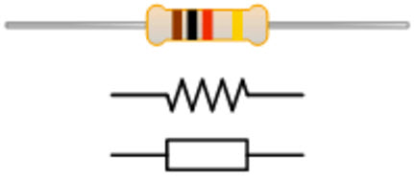 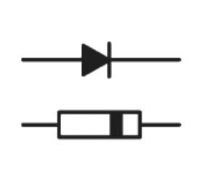 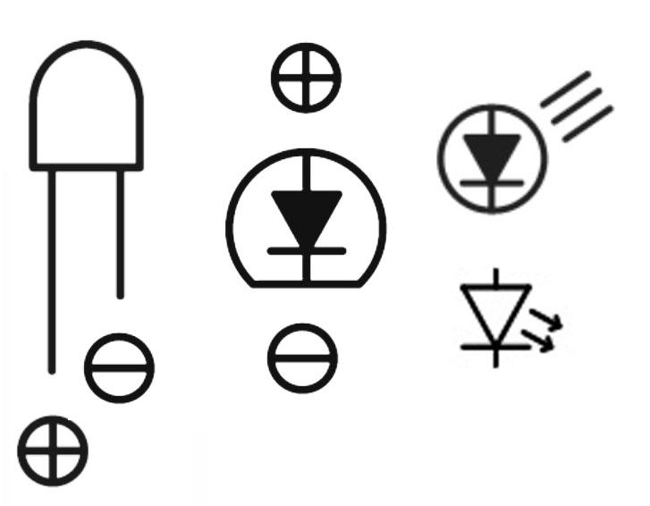

Resistor Symbols Diode Symbols (polarized) LED symbols(polarized):

Negative (Flat) Side: Cathode  
 Positive Side: Anode

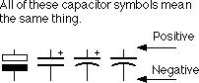 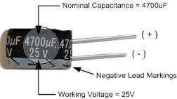

Capacitor Symbols (some polarized)

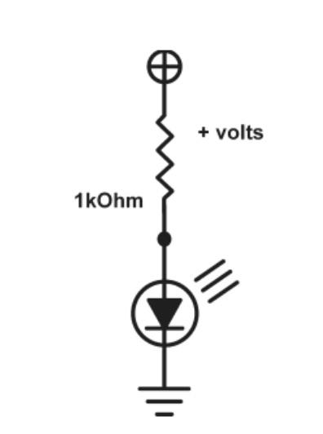 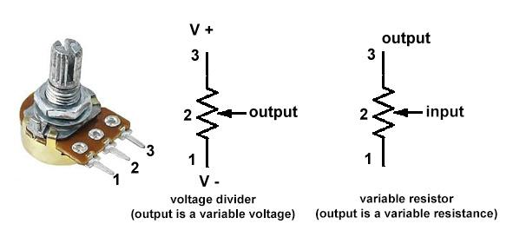

Complete LED Circuit Example

with Ground Symbol Potentiometer Symbols

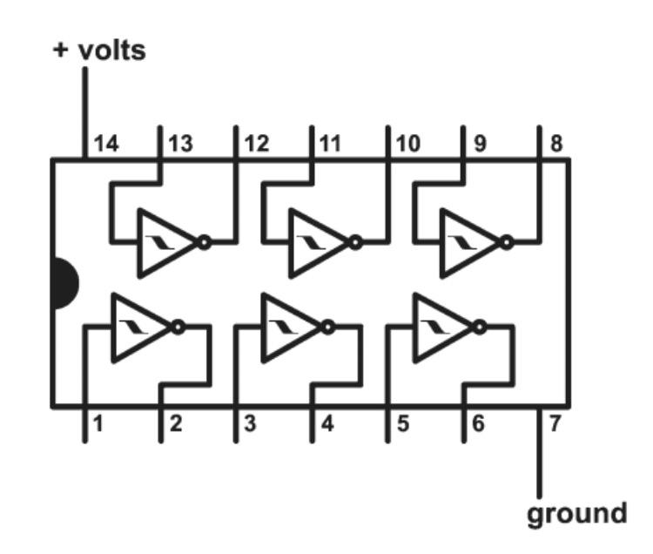 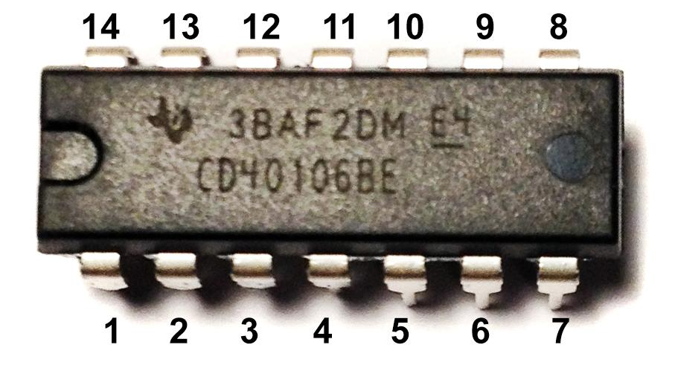

40106 IC Pinout and IC

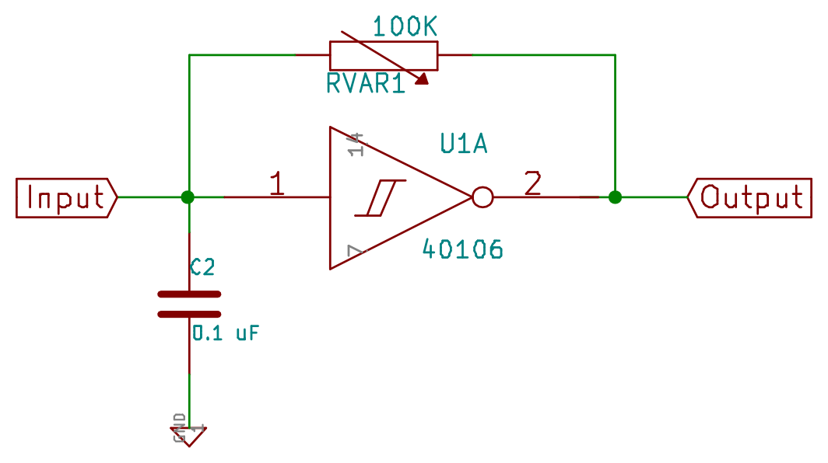 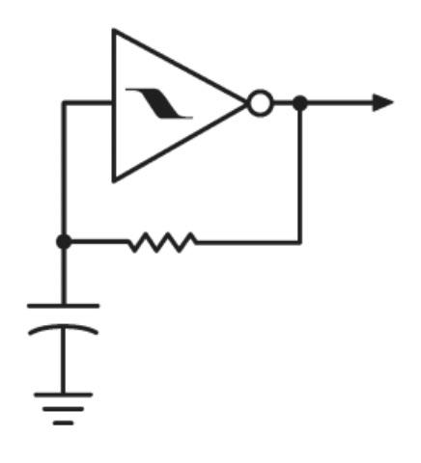

Simple 40106 oscillator schematic drawn with Kicad software Simple 40106 oscillator schematic

Wiring variations for the 40106

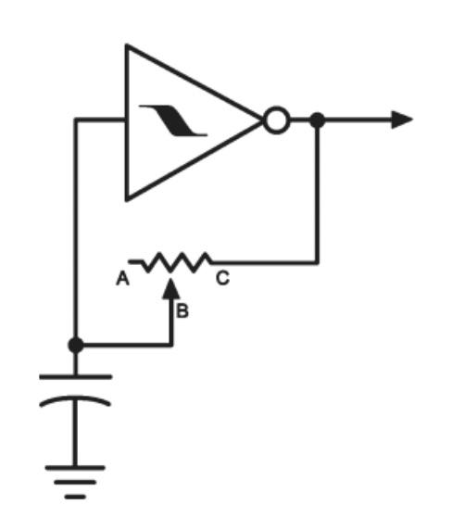 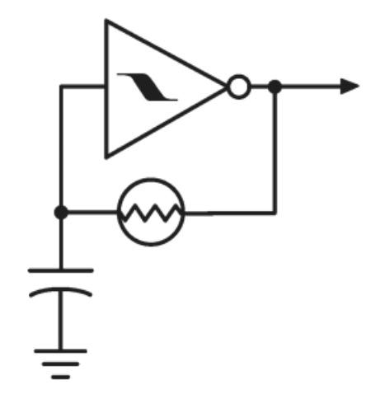 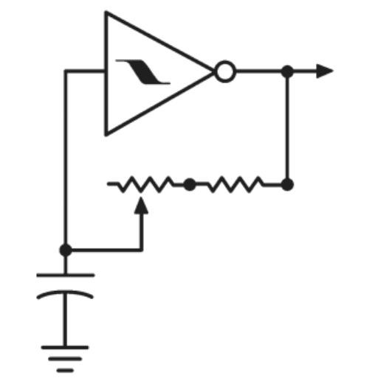

potentiometer controlled photocell controlled oscillator Fixed upper frequency limiter

tunable oscillator

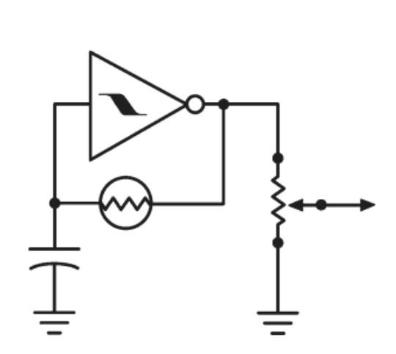 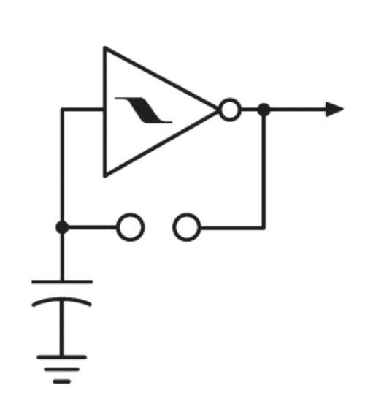 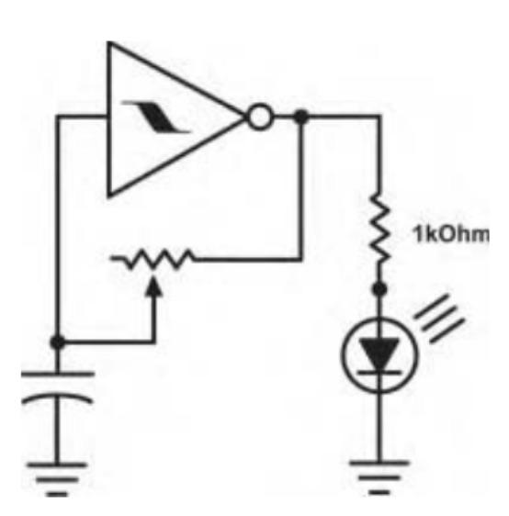

output volume control Electrode controlled oscillator Potentiometer controlled LED flasher

the electrodes can be bare (can be used as indicator light   
 wires, metal touchpoints, or with photocell for modulating

get creative with this! different effects)

Experiment with different sensors! flex sensors, pressure sensors, stretch sensors, graphite on paper, different metal objects as touch points, etc. Different resistive sensors will have 2 or 3 leads, and can be wired up similar to a potentiometer (3 leads) or a fixed resistor (2 leads)

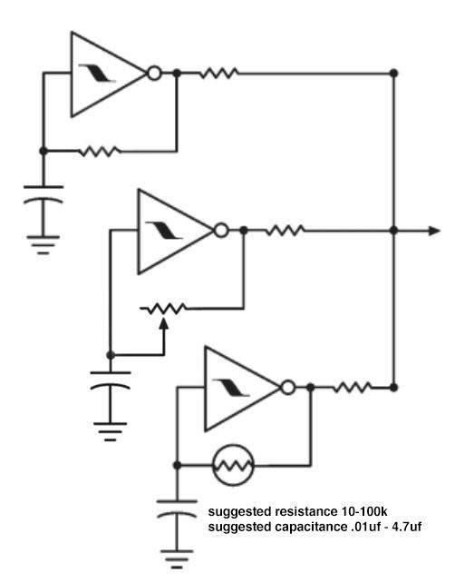 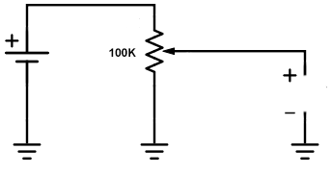

Using Resistors to mix together outputs (10k suggested) Using a potentiometer to starve power to the

40106 for more strange oscillator sounds

Using a diode to drive oscillators into each other

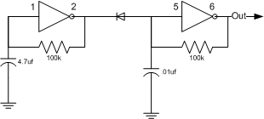

You can use an LED and photocell together to act as a variable resistor. These examples will duck the volume according to the brightness of the LED.

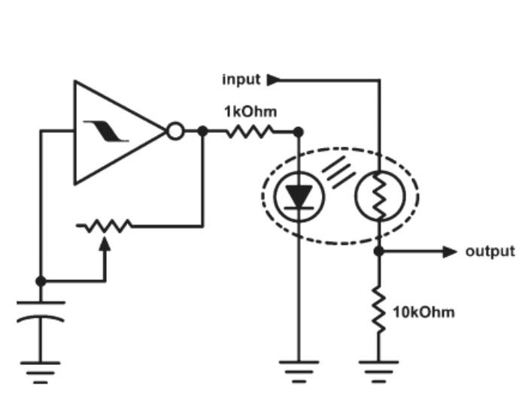

LED controlled Strobe Gate:

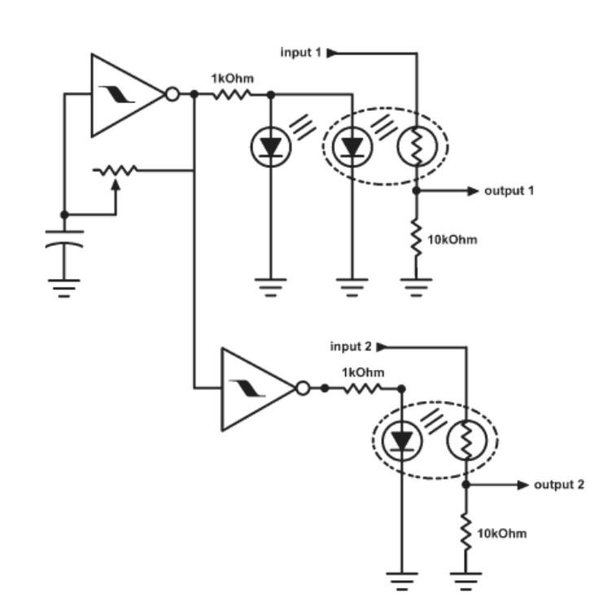

Blinking LED controlled Panner/Mixer:

The output volume will pan back and forth between the two outputs.

The 1kOhm is a limiting resistor for the LED, and the 10K ohm is an upper frequency limiter

Examples of how Photocells can be used for mixing and panning different audio inputs and outputs:

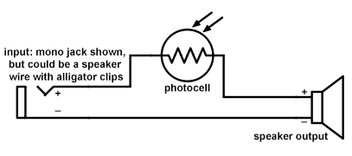

basic photoresistor gate circuit (ground symbol excluded)

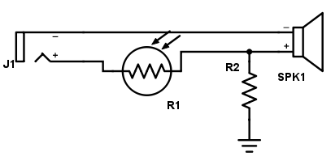

light controlled volume control

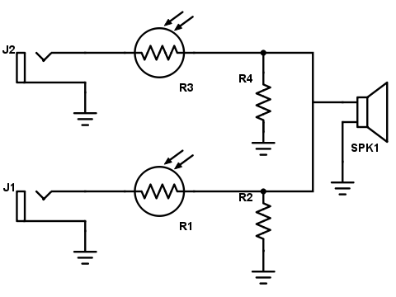

Light controlled stereo to mono mixers

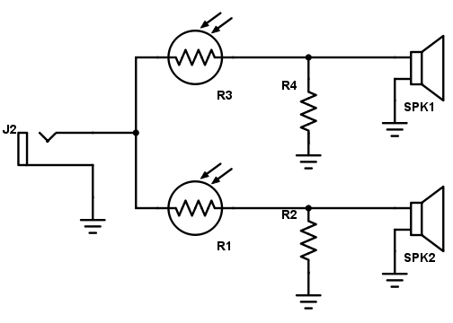

light controlled mono to stereo panner

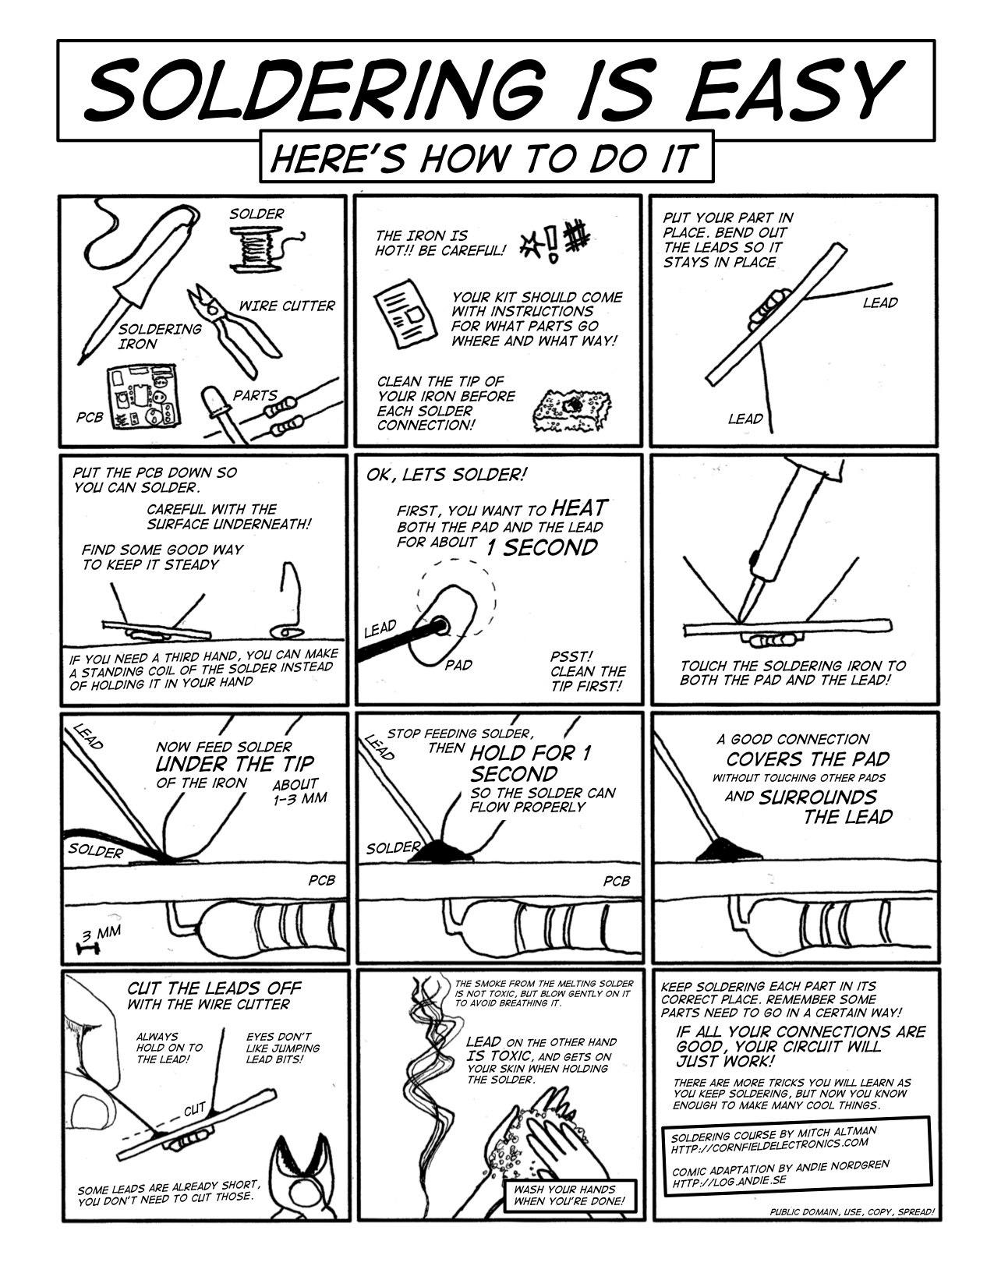

Soldering comic from CornField Electronics.com

Most circuit diagram images from Nicolas Collins “Handmade Electronic Music”

Suggested Reading: Adafruit tutorials, Sparkfun tutorials, Make: Electronics: Learning Through Discovery by Charles Platt, “Handmade Electronic Music” by Nicolas Collins

Dallas Shoutouts: Thanks to the Dallas Makerspace, a 24 hr hackerspace with a fully functioning electronics lab, with lots of components available for free for artists to utilize. There is lots of help available there if you are looking for local electronic mentorship, and Tanner Electronics is a great resource for purchasing individual electronic components.